Close Reading
On page 54, Alma's quest to prove herself is challenged when the weather creates a dangerous situation for the cattle. Find and underline the sentence here that shows the end result of Alma's efforts.

Hint
The final part of the story includes the resolution. Remember that the main character's problems are usually solved at this point.
Continue reading "Alma's First Cattle Drive." Use the Close Reading and the Hint to help you answer the question.
(continuedfrom page 54)
 | Part 3: Guided Instruction | Lesson 6
Alma stayed there in the stinging rain, her horse breathing hard beneath her. She was cold and hungry, but she kept her horse on the edge of the shallow riverbank until each animal had safely passed.
When she finally rode ashore; her father waved to get Alma's attention. He paused for just a moment to tip his hat to her before they continued. Alma knew then that she had proven herself to be a valuable member of the team.
Circle the correct answer.
Which sentence best shows the resolution of the story?
- "She was cold and hungry, but she kept her horse on the edge of the shallow riverbank until each animal had safely passed."
- "Alma stayed there in the stinging rain, her horse breathing hard beneath her."
- "When she finally rode ashore, her father waved to get Alma's attention."

D |  | "Alma knew then that she had proven herself to be a valuable member of the team."
Show Your Thinking
Explain how you could tell which choice was the resolution of the story.
With a partner, discuss the episodes that took place in this story. Decide whether the resolution is a satisfying conclusion to the story's events.
1.6: Describing Plot
55
©Curriculum Associates, LLC Copying is not permitted.
Which of these sentences shows how the plot is resolved?
  - "We were going along at a good pace, but the moment my feet touched the first part of the bridge I felt sure there was something wrong."
  - "Of course I could not tell him, but I knew very well that the bridge was not safe."
  - '"The bridge is broken in the middle, and part of it is carried away; if you come on you'll be into the river."'
  - '"No, my dear; but if your Black Beauty had not been wiser than we were we should all have been carried down the river at the wooden bridge."'
3
What is the main conflict in the story?
  - The storm causes a large branch to fall and nearly hit Black Beauty and the men.
  - The men want Black Beauty to cross the bridge, but he knows it is out.
C The bridge breaks and is washed away by the rising water.
- The master must go into town for business during a terrible storm.
Explain how Black Beauty's decision not to cross the bridge changes the story. Use at least two details from the story in your answer.

60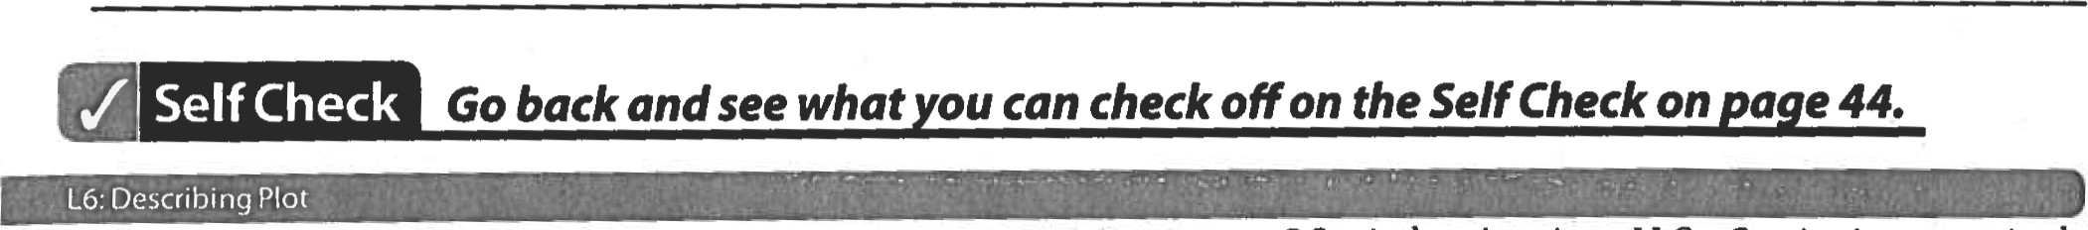
©Curriculum Associates, LLC Copying is not permitted.

